2019 SUMMER VACATION ACTIVTIES & GOALS (Sample)
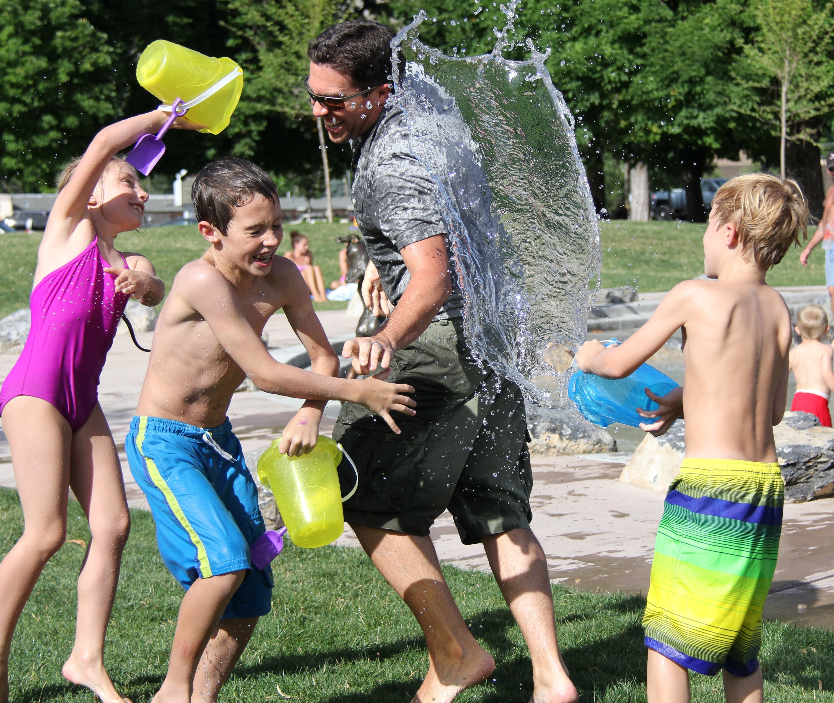

- Movie Night at the park
- Game night
- Play dates with friends
- Lake Powell
- Water fight
- Swim at the community pool
- Lagoon
- Hike
- Disneyland vacation
- Concerts at the park
- Play at the park
- Summer Camp
- Clean garage
- Feed homeless
- Library reading time for kids
- Academic Workbook
- Practice guitar 3 hours/week
- Cooking class (teach kids how to cook something new)
- Arts & Crafts
- Blow bubbles
- Learn a new language
- Exercise 4 times per week
- Read 5 books
- Bear Lake
- Water slide park
- Photo scavenger hunt
- Overnight visit at Grandma’s
- Carnival in the backyard with game booths. (hitting bottles with a ball, blowing bubbles through a hoop, face paint, chalk art, sidewalk bowling)
- Make homemade ice cream
- Other activities ________________________________________________________________________________________________________________

